Meadowcroft HOA

Minutes
Location: | Westside Academy Youth Room
Date: | January 27, 2026
Time: | 6:00 PM

Agenda details

Welcome – President Joe McFadden – (Shawn in Joe’s place)

Pastor Reed did the Invocation

Introduction

Board of Directors Review/Commitment to Bylaws – The board held a review of the bylaws to ensure they were well understood and being followed. The board committed to doing this annually.

Financials – Treasurer Carrie Maile

2025 Financial Review

A question was raised about how the picnic food trucks were paid. Bonnie Jean answered that each attendee received a meal ticket and a dessert ticket to give to the food trucks. The food trucks were capped at $15 for meals and $10 for desserts. They kept track of what was sold, and the tickets were received and paid for at the end of the night.

A question about the sprinkler needing repairs. It was discussed that the well, not the sprinklers, needed repair this year. It was also noted that the roots are what cause the sprinkler heads to go bad.

Carrie announced that the Finance Committee will review the books each year, as discussed in the special meeting last year. That review will begin after this meeting.

2026 Budget – Carrie reviewed the budget.

A concern was raised over the cars parked at the end of Fallingwater – the owner passed away, and the widow is in the process of cleaning that up.

A concern was raised over cars that are covered on Caitlyn Dr and a truck that brings in cars. A reply stated that the cars are special show cars and are in working order. The owner transports cars for work and sometimes brings in his work truck. There is no violation of the restricted covenants.

Don Demarte made a motion to approve the budget. Pastor Reed seconded the motion. President Jo called for a vote, and the motion carried.

A request was made for larger no soliciting signs. The board agreed to look into this issue.

Lawn Care Bid – due at end of month. The board will meet within 10 days of this meeting.

A question was raised about the holiday decorations and having someone paid to handle those. A line item was included in the lawn care RFP, and not all lawn care companies will do decorations– individual bids for decorations are appreciated.

New Business- Secretary Bonnie Jean Sherbert

New Website –

The new website is up and running. There is an owner's portal, and owners must request access. This portal can be a space for group discussions and is available to all owners. Facebook is open to all residents. Group rules of courtesy and respect apply to both.

The board would like to get some new pictures of the neighborhood for the website and is asking for help with that.

Flock Safety LPR Camera System – Information & Budget Impact Discussion

The HOW board was approached by Flock with a proposal. The board is bringing it to the owners for discussion to determine if there is enough interest for a special meeting.

Lee Monahan is an owner and is also with the Sheriff's department, who spoke on the topic.

These are highly regulated in how the city and county can use them. Everything is documented and justified.

In the first year of use – very effective – 15 units in the county – recovered 50 vehicles and numerous missing persons located – runaways. Biggest success story – Dec 2022- 8th day – attempted carjacking – man shot in the face – unit was 7/10 miles – led to arrest – carjacking, murder, 2 stolen vehicles in less than 24 hours.

Benefits to Meadowcroft – reduce/eliminate car thefts from out of town, looking for unlocked cars. Alerts the Sheriff's department when a stolen car enters the neighborhood. We are a big target – one of the largest neighborhoods in area – and are just outside the city limits, in a rural area.

Flock is trying to deter theft but also provide evidence to law enforcement.

Flock proposed 2 cameras at each entrance. We could reduce costs and do one at each entrance or maybe wait at the back entrance.

This is a lease, not a purchase. So, Flock will replace cameras if stolen or damaged. – They take care of the maintenance. EX: A Drunk driver hit the pole. The sheriff had to pay for the pole, but Flock replaced the camera/solar panel. We don’t pay for the maintenance. We would need to make sure this is in the contract.

The database is nationwide – only kept for 30 days.

Jim Giffin suggested – Since consideration will raise dues, we need a list of justifications. Need some statistics on effectiveness and statistics on crime in our area. We would have the Flock salesman present at a special meeting.

There are other service providers, but they are more expensive and not as reliable with law enforcement. Law enforcement is the biggest customer.

Pastor Reed – suggest we investigate options.

Jim Giffin made a motion to move forward with a second meeting to discuss and vote. Pastor Reed seconded. The motion carried.

Important Dates – President Joe McFadden

Spring Yard Sale – Saturday, April 11, 8:00 AM to 2:00 PM

Fall Yard Sale – Saturday, October 3, 8:00 AM to 2:00 PM

Annual Picnic – Saturday, October 24th, 3:00 PM to 7:00 PM

Motion to adjourn made and seconded.

MEADOWCROFT HOMEOWNERS ASSOCIATION
Proposed Annual Operating Budget
Fiscal Year: 2026
Number of Homes: 356
Annual Assessment: $100 per home

Total Annual Revenue
- HOA Assessments (356 × $100) $35,600

Operating Expenses
Maintenance & Operations
- Lawn Care $20,000
- Utilities $1,200
- Repairs & Maintenance (Common Areas) $2,700
Subtotal $23,900
Administrative
- Insurance $1,500
- Technology & Communication Enhancement $460
- Rental Expenses $200
- PO Box Rental $192
- Office Supplies $400
Subtotal $2,752
Community & Beautification
- Beautification $1,400
- Community Picnic $7,000
Subtotal $8,400
Other
- Miscellaneous $548
Subtotal $548

Budget Summary
- Total Revenue: $35,600
- Total Expenses: $35,600
- Net Surplus / (Deficit): $0
- Status: Balanced Budget

Board Certification
This budget represents the anticipated operating expenses of the Homeowners Association for the stated fiscal year and is submitted for approval by the Board of Directors.
Treasurer: ___________________________ Date: __________
Board President: ______________________ Date: __________

Flock Safety LPR Cameras – Cost Overview
What’s Being Proposed
- 6 LPR cameras (two at each entrance)
- Records license plates of vehicles entering/exiting
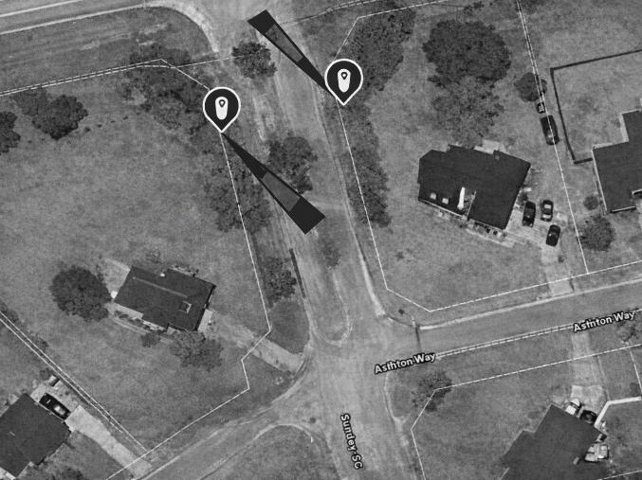
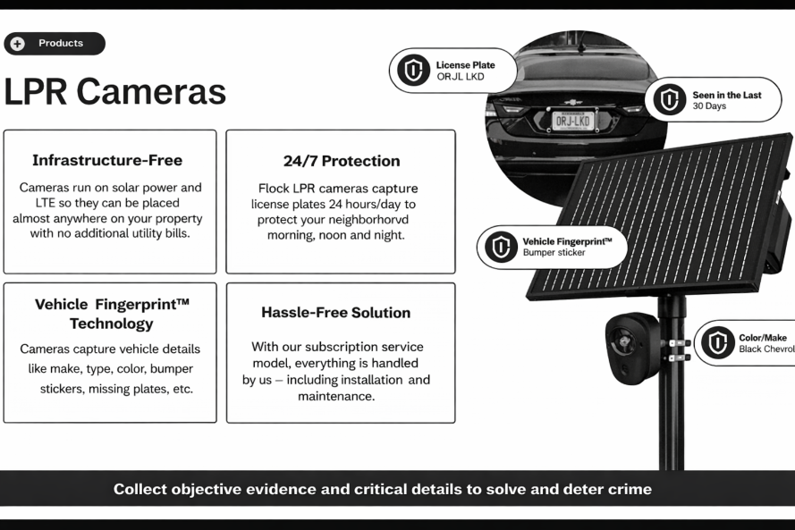
- Used for safety awareness and law enforcement assistance
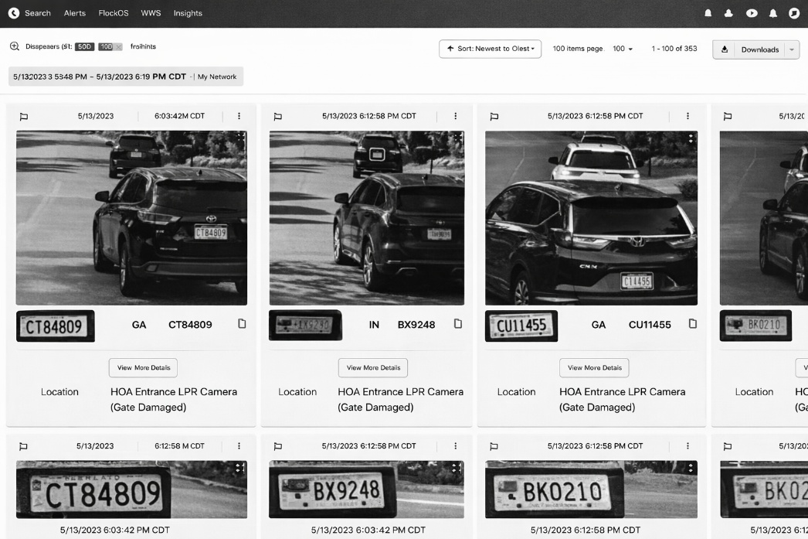

Cost Impact
- Year 1: $18,150 total
- Year 2: $14,250 total
- Dues Impact (356 Homes) $50 per household
What This Means
- Requires a budget increase
- Would result in an increase in annual dues
- No final decision has been made

This is an informational discussion. The Board will consider homeowner feedback, and a vote will occur before taking any action related to budget or dues changes.

✅ Pros

Crime Deterrence

Visible cameras at entrances can discourage theft, vandalism, and suspicious activity.

May reduce “drive-through” crimes by non-residents.

Investigative Support

Provides time-stamped vehicle data that can assist law enforcement after an incident.

Helpful in cases of package theft, property damage, or hit-and-run incidents.

Entrance-Focused Monitoring

Cameras are placed only at entrances, not inside the neighborhood.

Does not track individuals on foot or record audio.

Faster Information Sharing

Allows the HOA to quickly provide relevant vehicle information when an incident occurs.

Reduces reliance on eyewitness memory or doorbell footage alone.

Potential Insurance & Safety Benefits

Some communities report an improved sense of safety among residents.

May support broader neighborhood safety initiatives (though not guaranteed to reduce crime).
⚠️ Cons & Considerations

Privacy Concerns

Captures license plates of residents, guests, and service providers.

Some homeowners may feel monitored, even if data use is limited.

Data Retention & Access

Data is stored by a third-party vendor.

Clear policies are required for who can access data and how long data is retained, and when information is shared with law enforcement

Cost & Dues Impact

Adds a recurring operating expense.

Requires a dues increase to fund installation and ongoing service.

Not Preventive in Real Time

LPR cameras do not stop crimes as they occur.

Primarily useful for post-incident investigation, not active monitoring.

Potential for Mission Creep

Without strong governance, concerns can arise about:

Overuse of data

Expanding camera usage beyond original intent

🛡️ Best Practices If HOA Moves Forward
If adopted, many HOAs implement safeguards such as:
  - Limiting access to 1–2 designated board members
  - Retention limits (e.g., 30 days unless part of an active investigation)
  - No real-time monitoring by residents
  - No use for HOA enforcement or tracking homeowner behavior
  - Clear written privacy and data-use policy shared with homeowners

